課堂剪輯影片上傳步驟

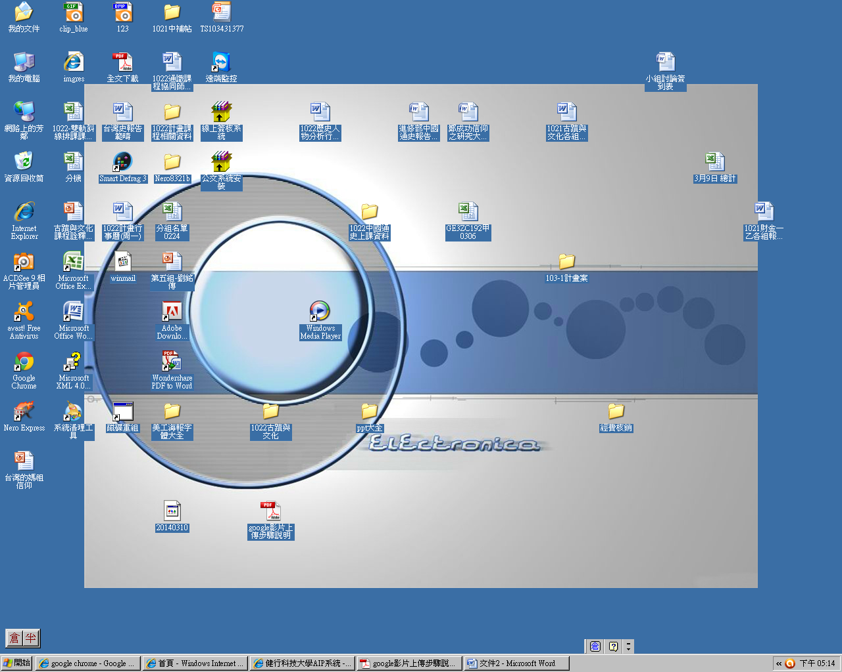

1. 打開google chrome

已申請(免費空間為15G):

• 帳號:geuch2vod@gmail.com

• 密碼:uchschool

2.複製下面的網址

• <https://accounts.google.com/ServiceLogin?service=wise&passive=1209600&continue=https%3A%2F%2Fdrive.google.com%2F%3Ftab%3Dmo%26authuser%3D0%26urp%3Dhttp%3A%2F%2Fwww.google.com%2Faccounts%2FLogout2%3Fhl%253Dzh_TW%2526se%26urp%3Dhttp%3A%2F%2Fwww.google.com%2Faccounts%2FLogout2%3Fhl%253Dzh_TW%2526se%23&followup=https%3A%2F%2Fdrive.google.com%2F%3Ftab%3Dmo%26authuser%3D0%26urp%3Dhttp%3A%2F%2Fwww.google.com%2Faccounts%2FLogout2%3Fhl%253Dzh_TW%2526se%26urp%3Dhttp%3A%2F%2Fwww.google.com%2Faccounts%2FLogout2%3Fhl%253Dzh_TW%2526se&ltmpl=drive>

3.將上面網址貼到google chrome的網址列上

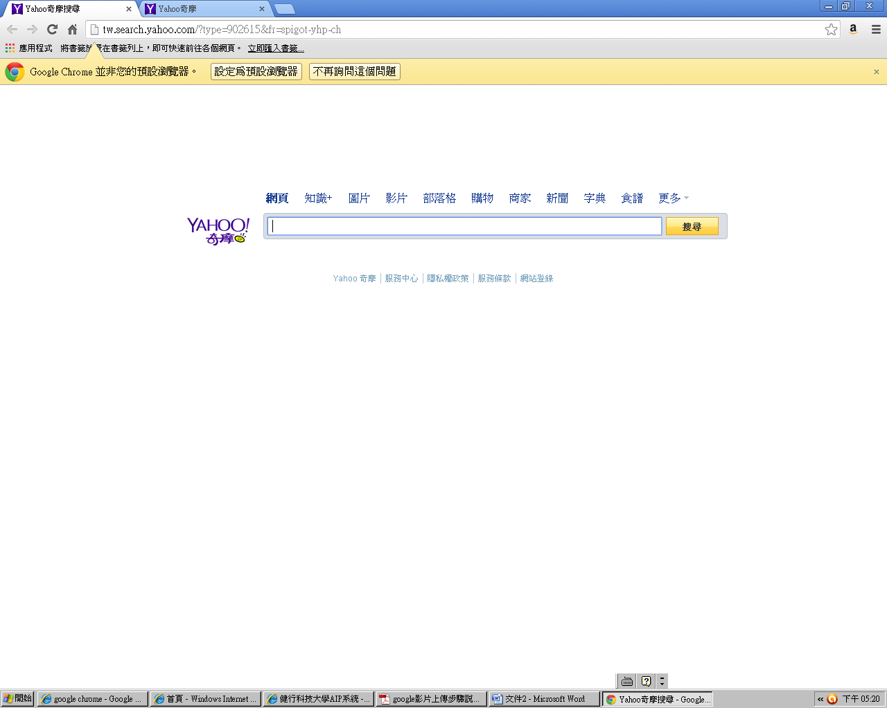

4.按enter

5.點選vod

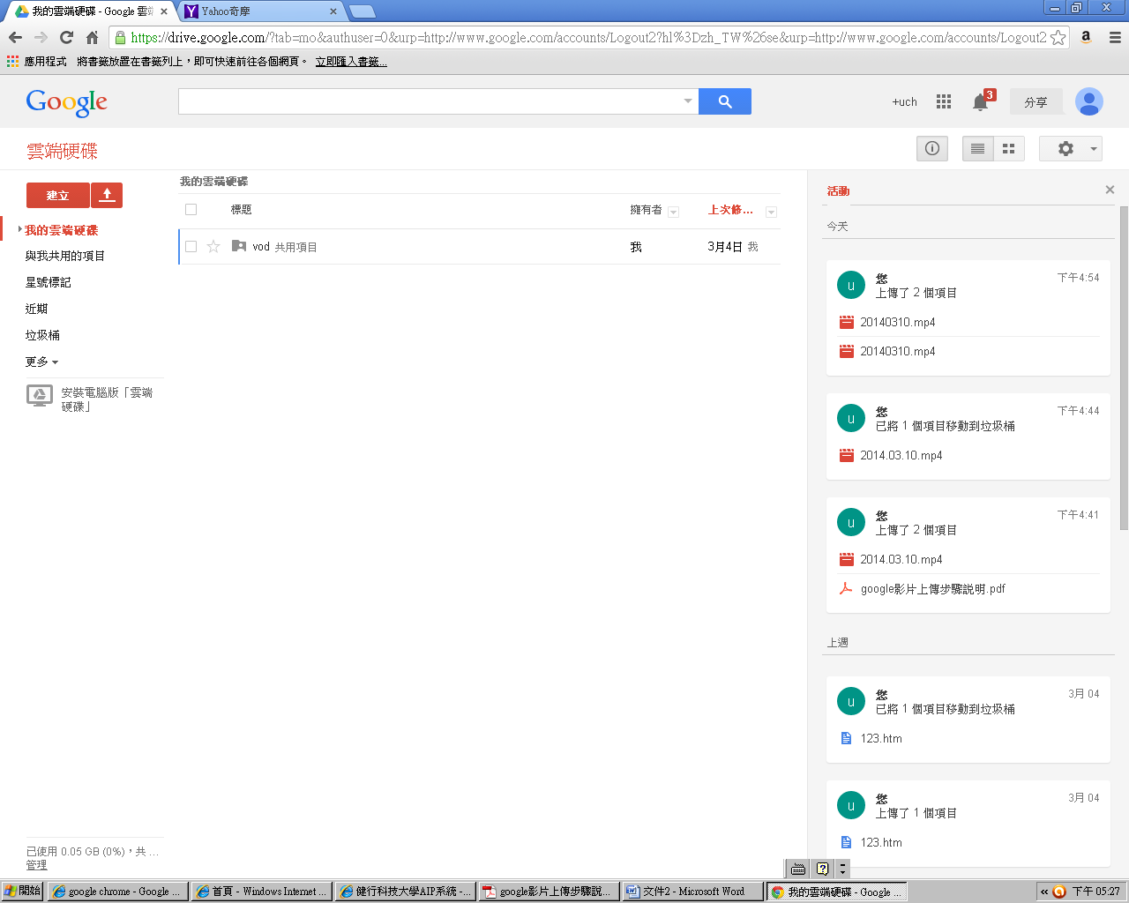

6.再按上傳你已備妥的檔案

7.上傳後，再點選已上傳的影片檔案

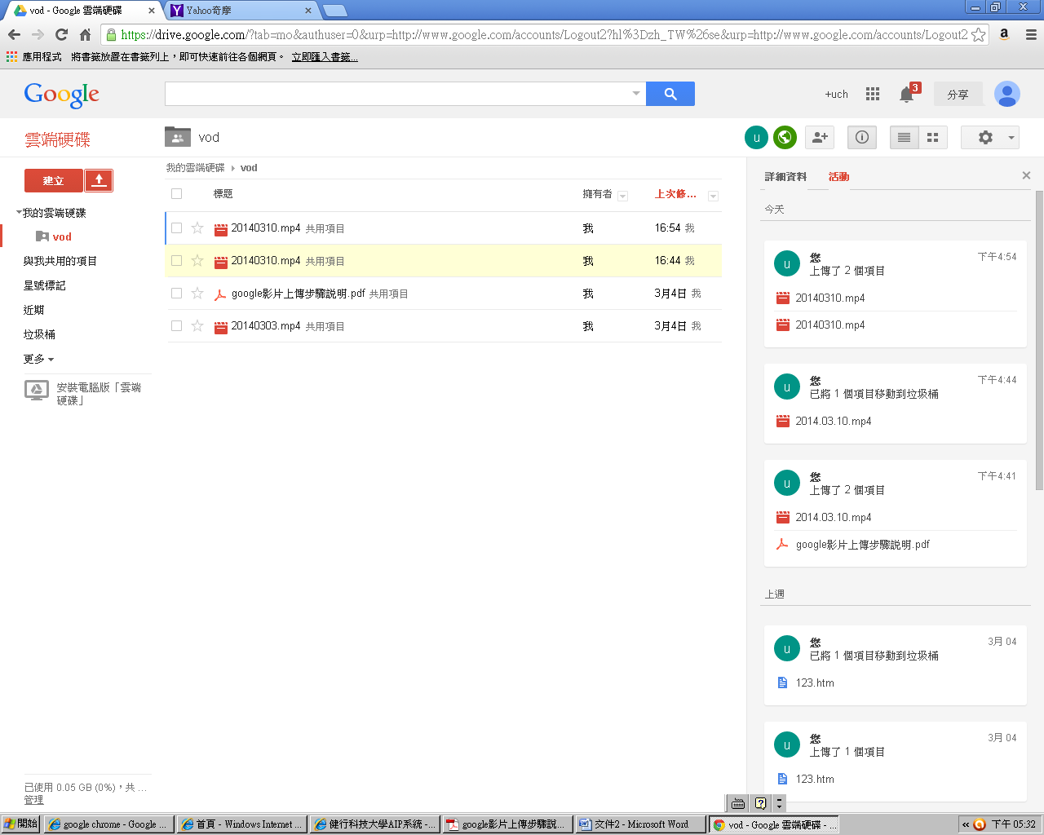

8.點選檔案按右鍵→選擇開啟工具→雲端硬碟檢視器

9.再按檔案→嵌入這部影片

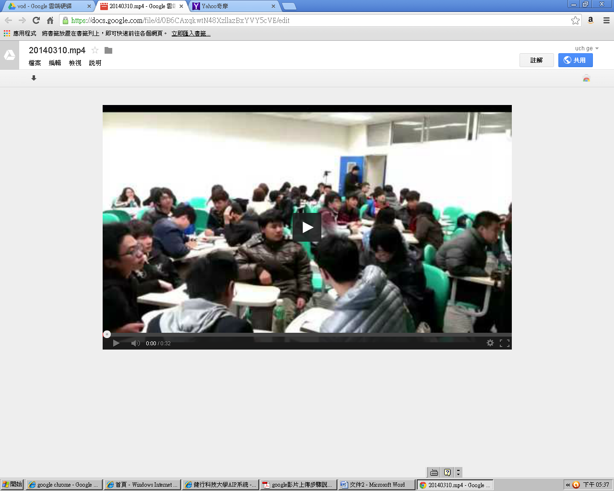

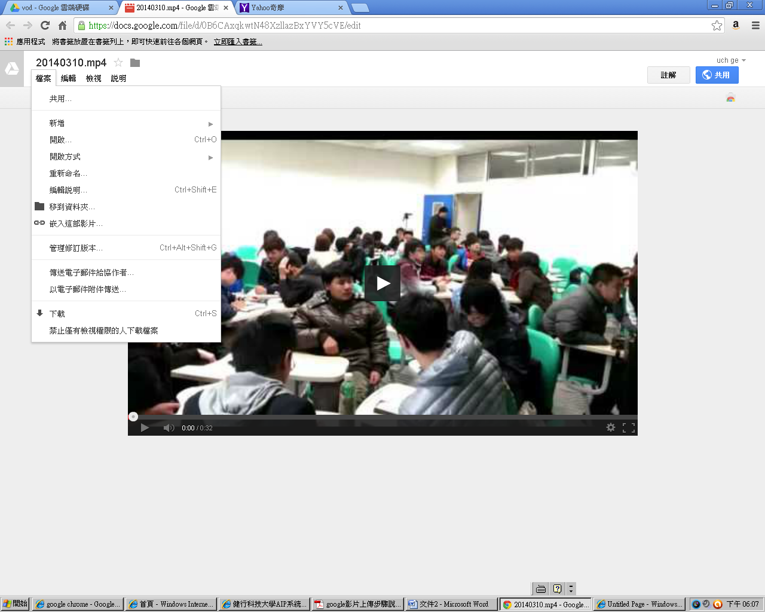

10.複製出現的語法

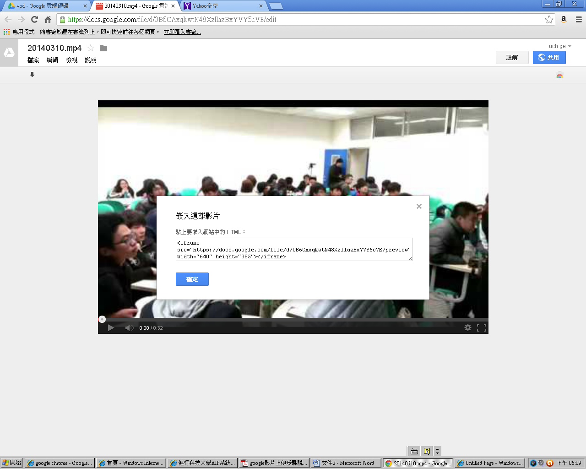

11.回到我們的網站要放影片的位置→按編輯→再按＜＞→貼上→確認→確認

